**Global sales Data Analytics**

|  |  |
| --- | --- |
| **Date** | 16-11-2022 |
| **Team id** | PNT2022TMID45267 |
| **Project Name** | GlobalsalesDataAnalytics |

Sprint delivery plan

The Benefits of Sprint Planning

The sprint planning event, when done right, sets the team up for success by getting everyone on the same page. It helps team members focus their efforts anstay motivated. Here’s why you should invest in your sprint planning proces

* Understand team capabilities

Get an overview of each team member’s workload to allocate resources effectively. The process also helps the team keep the big picture in mind to address skill gaps proactively.

* Manage expectations:

Review backlog items and agree on what will be addressed in each sprint so teams can monitor their capacities. Setting up frequent feedback loops also allows you to catch issues early to avoid costly rework.

* Foster clarity and transparency:

Reiterate the three pillars of Scrum — transparency, inspection, and adaptation to guide the team to work together efficiently (e.g., by collaborating on a digital scrum board.)

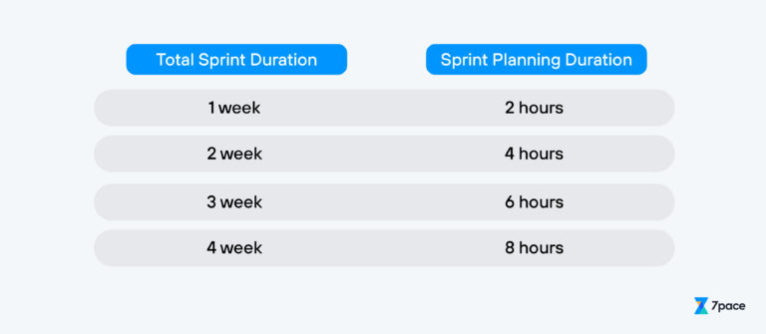Sprint Planning Meeting

Before going into a sprint meeting, the Scrum team should gather the right input to help them determine what value it can realistically deliver during the length of the sprint. These inputs include:

* Product backlog items (PBIs):

Evaluate PBIs in detail, prioritize their importance, and estimate the efforts required (e.g., story points.)

* Product roadmap:

Review the strategic direction of the product and its functionalities to ensure that the PBIs are aligned with the roadmap work items.

* Constraints and impediments:

Identify business or technical limitations that could affect the team’s ability to deliver the desired outcomes.

* Team velocity:

Understand the team’s velocity based on historical data to determine how much work it can complete within a sprint

## **Effective Sprint Planning Meeting**

* What can you deliver within the duration of the sprint?
* How will you accomplish the work needed to achieve the results

